# Apply filters to SQL queries

## Project description

Investigar problemas de segurança para ajudar a manter o sistema seguro. Recentemente, você descobriu alguns possíveis problemas de segurança que envolvem tentativas de login e máquinas de funcionários. Vamos examinar as tabelas employees e log_in_attempts. Vamos usar filtros SQL para recuperar registros de diferentes conjuntos de dados e investigar os possíveis problemas de segurança.

## Retrieve after hours failed login attempts

SELECT * FROM log_in_attempts WHERE login_time > '18:00:00' AND success = 0;

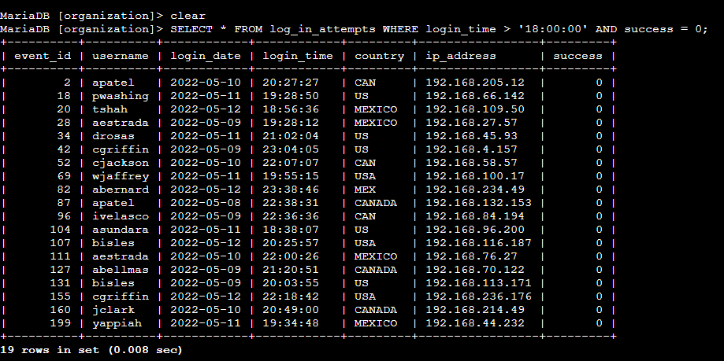

## Retrieve login attempts on specific dates

SELECT * FROM log_in_attempts WHERE login_date = '2022-05-09' OR login_date = '2022-05-08';

Example:

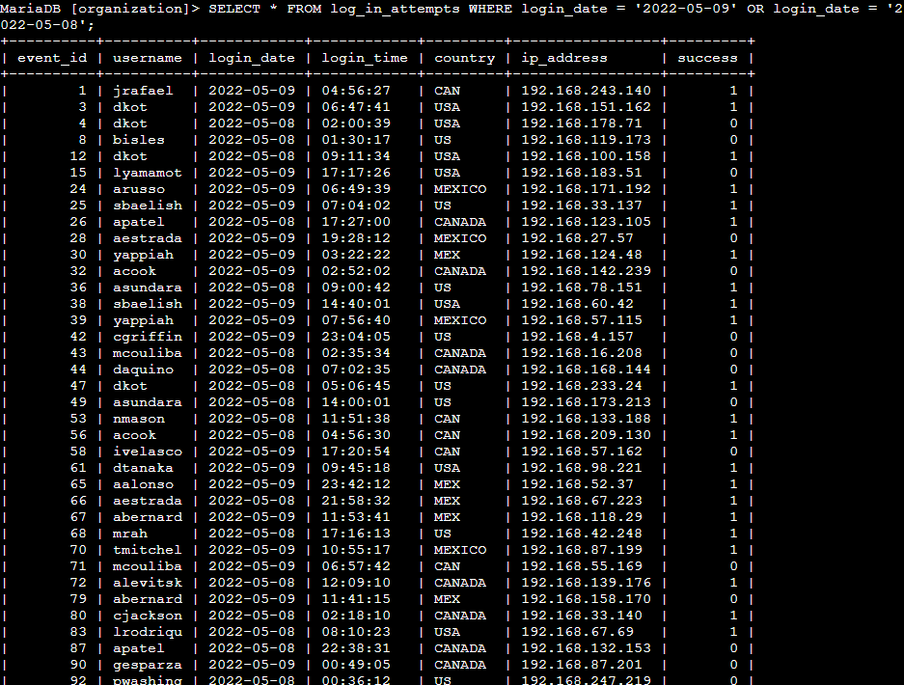

## Retrieve login attempts outside of Mexico

SELECT * FROM log_in_attempts WHERE NOT country LIKE 'MEX%';

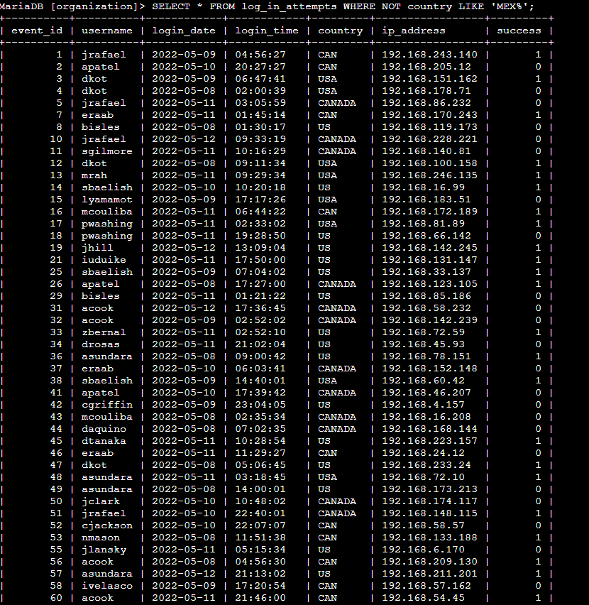

## Retrieve employees in Marketing

SELECT *

-> FROM employees

-> WHERE department = 'Marketing' AND office LIKE 'East%';

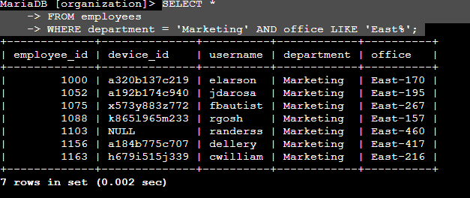

## Retrieve employees in Finance or Sales

SELECT * FROM employees WHERE department = 'Sales' OR department = 'Finance';

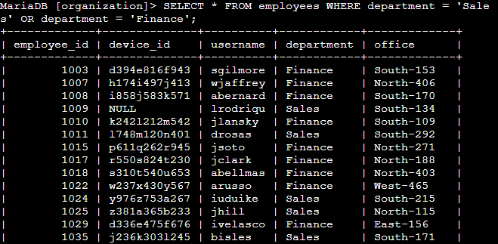

## Retrieve all employees not in IT

MariaDB [organization]> SELECT * FROM employees WHERE NOT department = 'Information Technology';

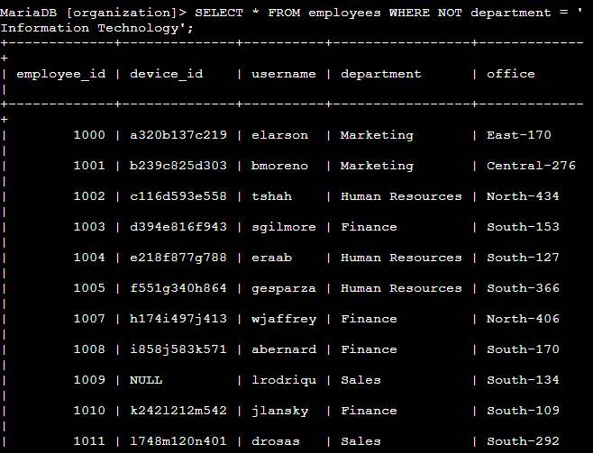

## Summary

We discover any hacking attempts that pose a security risk outside of Mexico. I search the databases for information about login attempts after 6pm. We study the Sales, Marketing and Finance department. We think the security risk is in departments outside of Information Technology.

The exercise is part of my cybersecurity training and I hope it helps you know how to use SQL to protect your system against hackers.